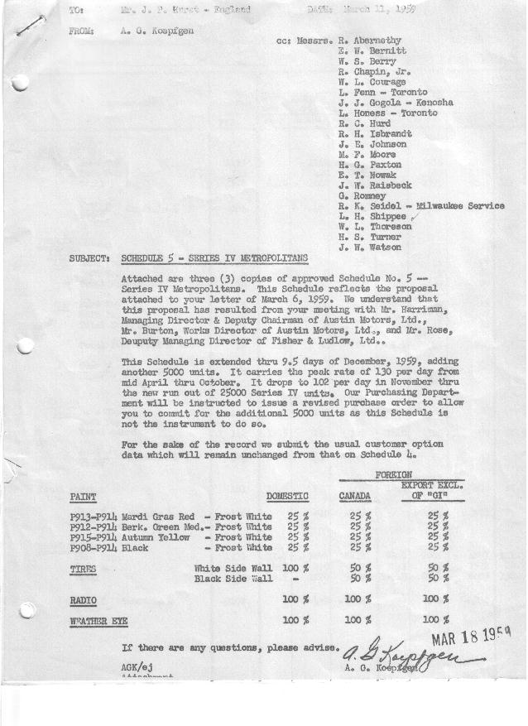

FORM AM 1262 Page 1 of 2 APPROVED R. Abernethy (signed) DATE 3-12-59

SCHEDULE NO. ______5 ___ DATE 3-11-59 MONTHLY BUILDING SCHEDULE APPROVED E.W.Bernitt (signed) DATE_ 3-16-59 _
REVISION NO. _______ __ ____ DATE PRODUCT APPROVED R. W.Chapin Jr. (signed) DATE _ 3-17-59 ____
SERIES IV 1500 c.c. ENGINE
METROPOLITAN SERIES CARS – AUSTIN MOTORS CO., LTD, ENGLAND
DESCRIPTION | BUILT  ◻ACT EST  THRU  FEB. | FIRM BUILDING SCHEDULE  (FABRICATED MATERIAL RELEASE) |  |  |  |  |  |  |  |  |  |  |  |  |  |  | TENTATIVE SCHEDULE  (RAW MATERIAL RELEASED) |  |  | GRAND  TOTAL
DESCRIPTION | BUILT  ◻ACT EST  THRU  FEB. | MONTH MARCH  DAYS 20 |  |  | MONTH APRIL  DAYS 22 |  |  | MONTH MAY  DAYS 19 |  |  | MONTH JUNE  DAYS 22 |  |  | MONTH JULY  DAYS 18 |  |  | MONTH AUGUST  DAYS 16 |  |  | GRAND  TOTAL
DESCRIPTION | BUILT  ◻ACT EST  THRU  FEB. | DAILY | MONTH | CUM’L  TOTAL | DAILY | MONTH | CUM’L  TOTAL | DAILY | MONTH | CUM’L  TOTAL | DAILY | MONTH | CUM’L  TOTAL | DAILY | MONTH | CUM’L  TOTAL | DAILY | MONTH | CUM’L TOTAL | GRAND  TOTAL
DOMESTIC LHD:
Hard-Top | 1193 |  | 1260 | 2453 |  | 1796 | 4249 |  | 1676 | 5925 |  | 2000 | 7925 |  | 1827 | 9752 |  | 1630 | 11382
Soft-Top | 335 |  | 420 | 755 |  | 599 | 1354 |  | 559 | 1913 |  | 650 | 2563 |  | 348 | 2911 |  | 310 | 3221
Total U.S. | 1528 | 84.0 | 1680 | 3208 | 108.9 | 2395 | 5603 | 117.6 | 2235 | 7838 | 120.5 | 2650 | 10488 | 120.8 | 2175 | 12663 | 121.3 | 1940 | 14603
Over/(Under) Schedule 4 | (986) |  | (420) | (1406) |  | (341) | (1747) |  | (137) | (1884) |  | (161) | (2045) |  | (144) | (2189) |  | (128) | (2317)
FOREIGN:
EXPORT LHD Hard-Top | 12 |  | 23 | 32 |  | 24 | 59 |  | 20 | 79 |  | 20 | 99 |  | 30 | 129 |  | 30 | 159
Soft-Top | 4 |  | 8 | 12 |  | 9 | 21 |  | 7 | 28 |  | 7 | 35 |  | 10 | 45 |  | 10 | 55
Total Export LHD | 16 |  | 31 | 47 |  | 33 | 80 |  | 27 | 107 |  | 27 | 134 |  | 40 | 174 |  | 40 | 214
RHD Hard Top | 3 |  | 6 | 9 |  | 10 | 19 |  | 6 | 25 |  | 6 | 31 |  | 7 | 38 |  | 7 | 45
Soft Top | 0 |  | 3 | 3 |  | 4 | 7 |  | 2 | 9 |  | 2 | 11 |  | 3 | 14 |  | 3 | 17
Total Export RHD | 3 |  | 9 | 12 |  | 14 | 26 |  | 8 | 34 |  | 8 | 42 |  | 10 | 52 |  | 10 | 62
Total Export LHD & RHD | 19 | 2.0 | 40 | 59 | 2.1 | 47 | 106 | 1.8 | 35 | 141 | 1.6 | 35 | 176 | 2.8 | 50 | 226 | 3.1 | 50 | 276
Over/(Under) Schedule 4 | (58) |  | (10) | (68) |  | (3) | (71) |  | (15) | (86) |  | (15) | (101) |  | -0- | (101) |  | -0- | (101)
CANADA Hard-Top | 130 |  | 185 | 315 |  | 255 | 570 |  | 180 | 750 |  | 175 | 925 |  | 115 | 1040 |  | 90 | 1130
Soft-Top | 12 |  | 65 | 77 |  | 53 | 130 |  | 20 | 150 |  | -0- | 150 |  | -0- | 150 |  | -0- | 150
Total Canada | 142 | 12.5 | 250 | 392 | 14.0 | 308 | 700 | 10.5 | 200 | 900 | 7.9 | 175 | 1075 | 6.4 | 115 | 1190 | 5.6 | 90 | 1280
Over/(Under) Schedule 4 | (58) |  | -0- | (58) |  | -0- | (58) |  | 58 | -0- |  | -0- | -0- |  | -0- | -0- |  | -0- | -0-
Total Foreign | 161 | 14.5 | 290 | 451 | 16.1 | 355 | 806 | 12.4 | 235 | 1041 | 9.5 | 210 | 1251 | 9.2 | 165 | 1416 | 8.7 | 140 | 1556
Over/(Under) Schedule 4 | (116) |  | (10) | (126) |  | 55 | (71) |  | (15) | (86) |  | (15) | (101) |  | -0- | (101) |  | -0- | (101)
GRAND TOTALS
Hard-Top | 1338 | 73.7 | 1474 | 2812 | 94.8 | 2085 | 4897 | 111.3 | 1882 | 6779 | 111.9 | 2201 | 8980 | 109.9 | 1979 | 10959 | 109.8 | 1757 | 12716
Soft-Top | 351 | 24.8 | 496 | 847 | 30.7 | 665 | 1512 | 26.7 | 588 | 2100 | 26.1 | 659 | 2759 | 20.1 | 361 | 3120 | 20.2 | 323 | 3443
Total | (1102) | 98.5 | 1970 | 3659 | 125.0 | 2750 | 6409 | 130.0 | 2470 | 8879 | 130.0 | 2860 | 11739 | 130.0 | 2340 | 14079 | 130.0 | 2080 | 16159
Over/(Under) Schedule 4 |  |  | (430) | (1532) |  | (286) | (1818) |  | (152) | (1970) |  | (176) | (2146) |  | (144) | (2290) |  | (128) | (2418)

FORM AM 1262 Page 2 of 2 APPROVED R. Abernethy (signed) DATE 3-12-59

SCHEDULE NO. ______5 ___ DATE 3-11-59 MONTHLY BUILDING SCHEDULE APPROVED E.W.Bernitt (signed) DATE_ 3-16-59 _
REVISION NO. _______ __ ____ DATE PRODUCT APPROVED R. W.Chapin Jr. (signed) DATE _ 3-17-59 ____
SERIES IV 1500 c.c. ENGINE
METROPOLITAN SERIES CARS – AUSTIN MOTORS CO., LTD, ENGLAND
DESCRIPTION | BUILT  ◻ACT◻ EST  THRU | FIRM BUILDING SCHEDULE  (FABRICATED MATERIAL RELEASE) |  |  |  |  |  |  |  |  |  |  |  |  |  |  | TENTATIVE SCHEDULE  (RAW MATERIAL RELEASED) |  |  | GRAND  TOTAL
DESCRIPTION | BUILT  ◻ACT◻ EST  THRU | MONTH SEPTEMBER  DAYS 22 |  |  | MONTH OCTOBER  DAYS 22 |  |  | MONTH NOVEMBER  DAYS 21 |  |  | MONTH DECEMBER  DAYS 9.5 (21 Available) |  |  | MONTH  DAYS |  |  | MONTH  DAYS |  |  | GRAND  TOTAL
DESCRIPTION | BUILT  ◻ACT◻ EST  THRU | DAILY | MONTH | CUM’L  TOTAL | DAILY | MONTH | CUM’L  TOTAL | DAILY | MONTH | CUM’L  TOTAL | DAILY | MONTH | CUM’L  TOTAL | DAILY | MONTH | CUM’L  TOTAL | DAILY | MONTH | CUM’L TOTAL | GRAND  TOTAL
DOMESTIC LHD:
Hard-Top |  |  | 2318 | 13700 |  | 2276 | 15976 |  | 1667 | 17643 |  | 820 | 18463
Soft-Top |  |  | 442 | 3663 |  | 434 | 4097 |  | 318 | 4415 |  | 156 | 4571
Total U.S. |  | 125.5 | 2760 | 17363 | 123.2 | 2710 | 20073 | 94.5 | 1985 | 22058 | 102.1 | 976 | 23034
Over/(Under) Schedule 4 |  |  | 1437 | (880) |  | 2710 | 1830 |  | 1985 | 3815 |  | 976 | 4791
FOREIGN:
EXPORT LHD Hard-Top |  |  | 30 | 189 |  | 30 | 219 |  | 30 | 249 |  | -0- | 249
Soft-Top |  |  | 10 | 65 |  | 10 | 75 |  | 10 | 85 |  | -0- | 85
Total Export LHD |  |  | 40 | 254 |  | 40 | 294 |  | 40 | 334 |  | -0- | 334
RHD Hard Top |  |  | 7 | 52 |  | 7 | 59 |  | 15 | 74 |  | -0- | 74
Soft Top |  |  | 3 | 20 |  | 3 | 23 |  | 5 | 28 |  | -0- | 28
Total Export RHD |  |  | 10 | 72 |  | 10 | 82 |  | 20 | 102 |  | -0- | 102
Total Export LHD & RHD |  | 2.3 | 50 | 326 | 2.3 | 50 | 376 | 2.9 | 60 | 436 |  | -0- | 436
Over/(Under) Schedule 4 |  |  | -0- | (101) |  | 50 | (51) |  | 60 | 9 |  | -0- | 9
CANADA Hard-Top |  |  | 50 | 1180 |  | 100 | 1280 |  | 100 | 1380 |  | -0- | 1380
Soft-Top |  |  | -0- | 150 |  | -0- | 150 |  | -0- | 150 |  | -0- | 150
Total Canada |  | 2.2 | 50 | 1330 | 4.5 | 100 | 1430 | 4.7 | 100 | 1530 | 0.0 | -0- | 1530
Over/(Under) Schedule 4 |  |  | -0- | -0- |  | 100 | 100 |  | 100 | 200 |  | -0- | 200
Total Foreign |  | 4.5 | 100 | 1656 | 6.8 | 150 | 1806 | 7.6 | 160 | 1966 | 0.0 | -0- | 1966
Over/(Under) Schedule 4 |  |  | -0- | (101) |  | 150 | 49 |  | 160 | 209 |  | -0- | 209
GRAND TOTALS
Hard-Top |  | 109.3 | 2405 | 15121 | 109.7 | 2413 | 17534 | 86.3 | 1812 | 19346 | 85.8 | 820 | 20166
Soft-Top |  | 20.7 | 455 | 3898 | 20.3 | 447 | 4345 | 15.8 | 333 | 4678 | 16.3 | 156 | 4834
Total |  | 130.0 | 2860 | 19019 | 130.0 | 2860 | 21879 | 102.1 | 2145 | 24024 | 102.1 | 976 | 25000
Over/(Under) Schedule 4 |  |  | 1437 | (981) |  | 2860 | 1879 |  | 2145 | 4024 |  | 976 | 5000

